**Road Racing in Mexico**

**Beginning a National Championship Year**

**by Tom King**

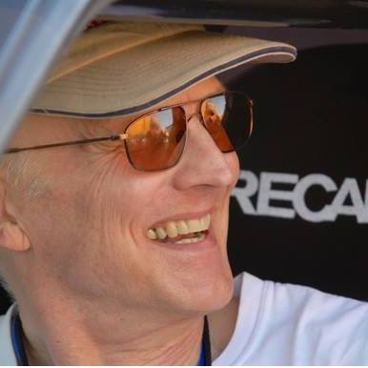

**Averting Disaster**

Cresting the hill at 100 mph, we burst upon a family in the middle of the road: mother, father, two small kids and a puppy in the left lane, a larger dog in the right lane, and Meme and I in the Silkrip NSX tearing down the middle. Racing in Mexico means your day can go from good to very bad in an instant.

*Immediate threshold braking, don’t lose control of the car sideways and collect them all, favor the right and hit the big dog if she moves, just trim her nose whiskers if she doesn’t. Give the family the most room possible. Please, nobody move.*

With the weight all on the front tires, scrubbing off speed, we slid past as they were frozen in place, mouths agape. *Check mirrors, everyone okay, our stage time ruined but not our lives.* It was pretty quiet in the car. We both knew how close to disaster that had been.

Racing in Mexico is dangerous and we accept that for ourselves, but this was the most serious peril I had encountered for innocent bystanders. They were probably spectating in the woods as the cars sped by at one-minute intervals when the big dog wandered into the road. I imagine them venturing tentatively into the road to call the dog back, and then their worst nightmare suddenly hurtled toward them. I hope they eventually got over feeling like quarks in a Large Hadron Collider.

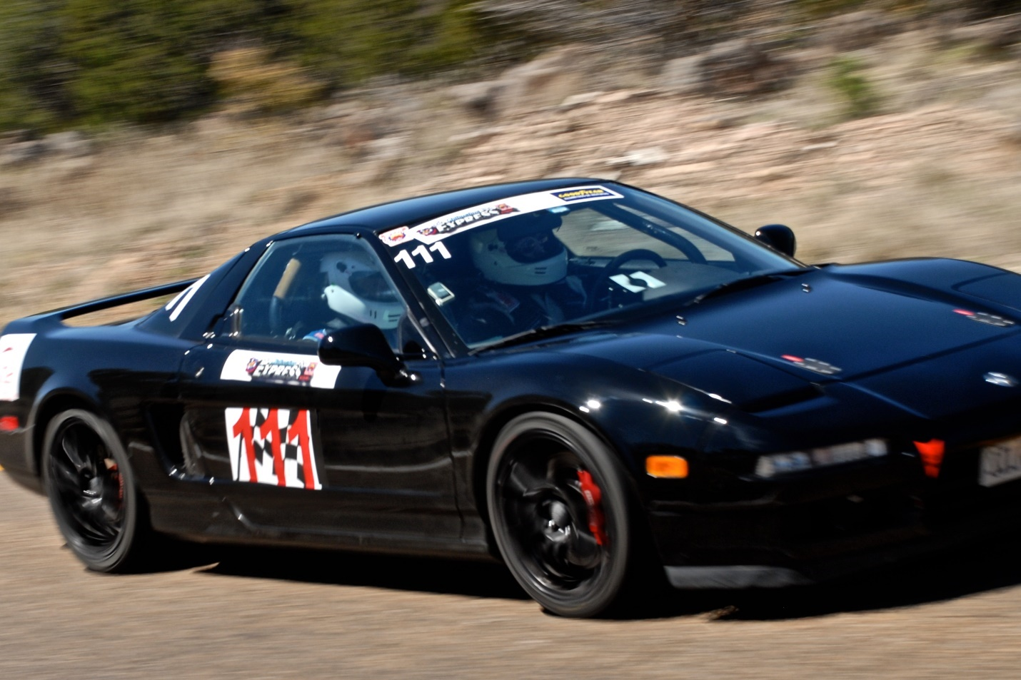

**The Chihuahua Express**

Three days of the Chihuahua Express, one thousand miles of special stage racing in the mountains on Mexican roads, this was the first event in our quest for the Open Road Racing championship, trying to make it three wins in three attempts in the same little black NSX that captured the series crown in 2003 and again in 2011. But this time, the car was having serious problems.

My “navigante” or navigator was once again the unflappable Meme Lozano, a former Mexican National Rally Champion navigator from Mexico City. Two years ago when we first ran this event, we only finished half of it, falling out due to a broken clutch. But we established an easy rapport in the car, and we also became friends, so we had a solid relationship this time when we met again in the parking lot of El Soberano Hotel, the race headquarters.

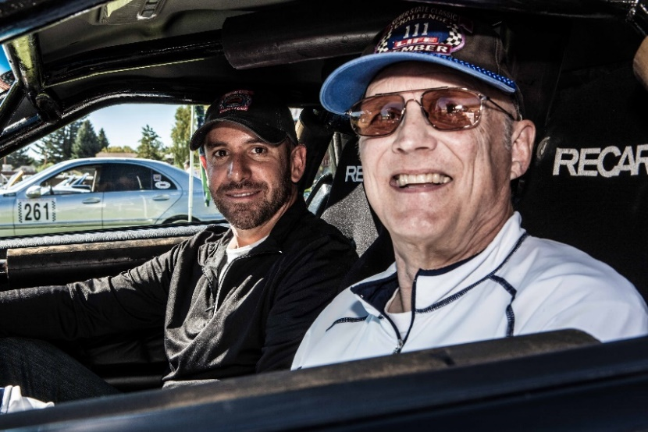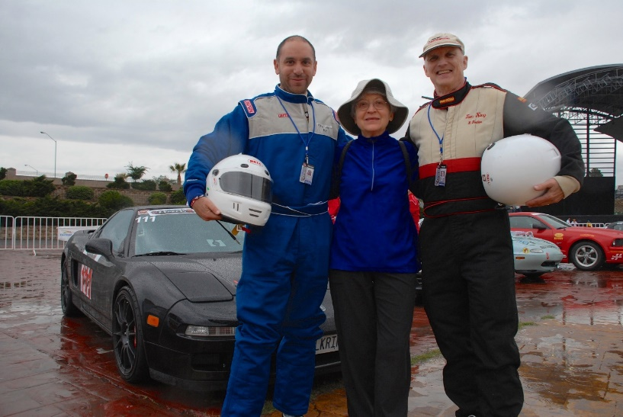

Meme, Val, and Tom Meme and Tom in NSX

This year, the Silkrip NSX had been struggling with a fuel vaporization problem in hot weather, and I wasn’t confident that I had resolved the issue in spite of modifications made after testing at Laguna Seca and at Thunderhill. Unfortunately, the problem reappeared with a vengeance in Mexico.

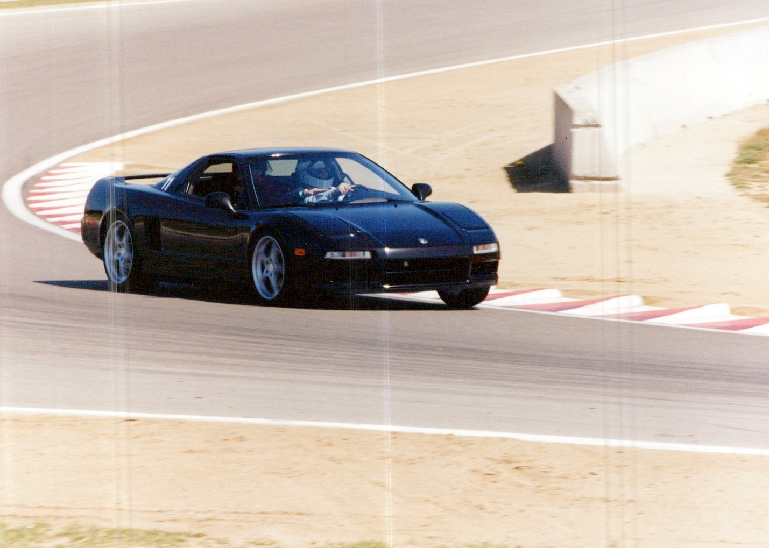

Testing at Laguna Seca Prior to Race

**Special Stage Racing**

Special Stage Racing is an endurance and speed test for man and machine. The police close a section of public road, usually 20 to 30 kilometers in length, the cars are started at one-minute intervals and timed for that section. Then there’s a “transit zone”, again on public roads but at legal speeds to get through the next village or town to the start line of another timed “special stage”. The winner is the one with the lowest accumulated time over all the special stages. Our top speed in the sinuous mountain stages of the Chihuahua Express was 144 mph according to our GPS, and our average speed was about 90 mph. In the U.S. events, our average speed was much higher due to the better road surfaces and fewer curves.

**Getting There is Half the Fun … or not**

Trailering the car, we stayed the first night in Blythe, California, a town on the Arizona border where I was sure they were going to make me hand in my ACLU membership card at the city limit. No Democrats allowed. At least that was according to a friend whose mother is from Blythe.

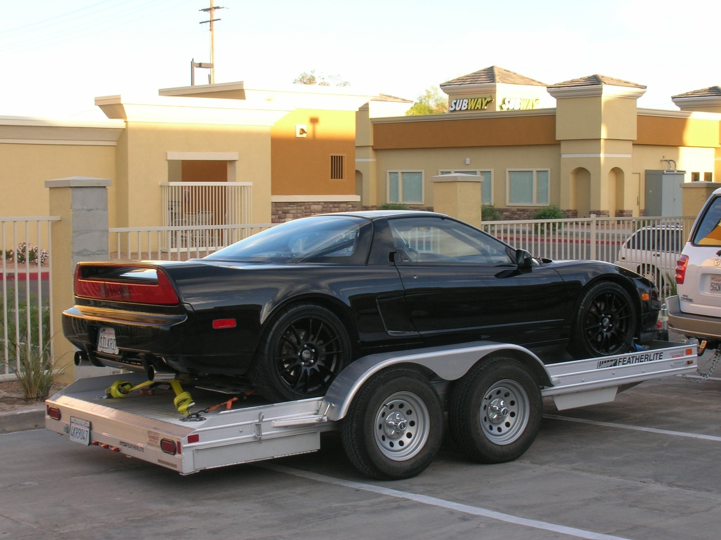

Then into Arizona, where even the cactus seemed to be giving us radical hippie socialists from California a bunch of rude gestures.

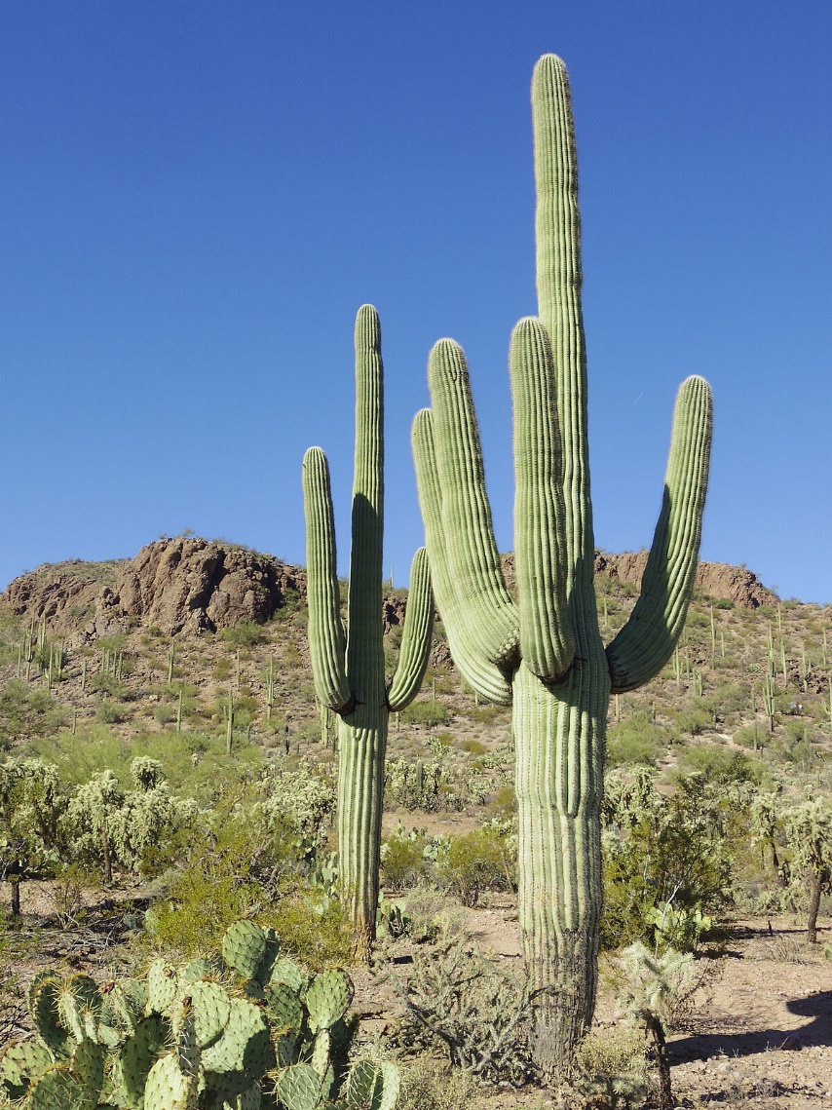

\

Welcome to Arizona

Val drove a couple of hundred-mile-plus legs in California and in Arizona. One of many reasons I love this woman. We eventually arrived in El Paso, Texas, where we met up with the caravan of U.S. racers that would be led the next day by Steve and Gail Waldman across the border and on to Chihuahua.

We dined at Rudy’s Country Store & Bar-B-Que, a place where you first gather up enough napkins to insulate a house and then dig in. Did I mention that Val is a vegan? And that she doesn’t care for cars or racing or long trips? She was in remarkably good spirits and enjoying the adventure.

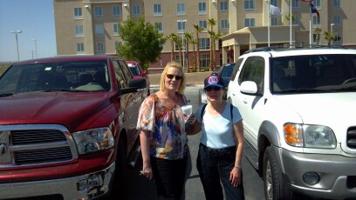

Gail Waldman and Val at Rudy’s in El Paso

**Stay Clear of Murder**

We crossed the border at Santa Teresa, New Mexico into Jeronimo, Mexico. This route would take us in a big loop to avoid the murder capital of the world, Ciudad Juarez. But Jeronimo must be the paperwork capital of the world, with many official forms required to take a tow vehicle filled with tools and parts, a trailer, and a race car into Mexico. Fortunately, we had been able to complete most of the work in advance via the Internet, so we were soon on our way and onto the toll road that leads to Chihuahua.

**Race Headquarters**

We pulled up to El Soberano Hotel in the early afternoon. I unloaded the NSX and drove it to a Pemex station to gas up. The car seemed to be running fine, but trouble was lurking like a mugger in a dark alley.

Meme and his girlfriend Roxana showed up on Thursday morning after their early flight from Mexico City. We adjusted the passenger side restraint system for him, tested the intercom, and set up the race car.

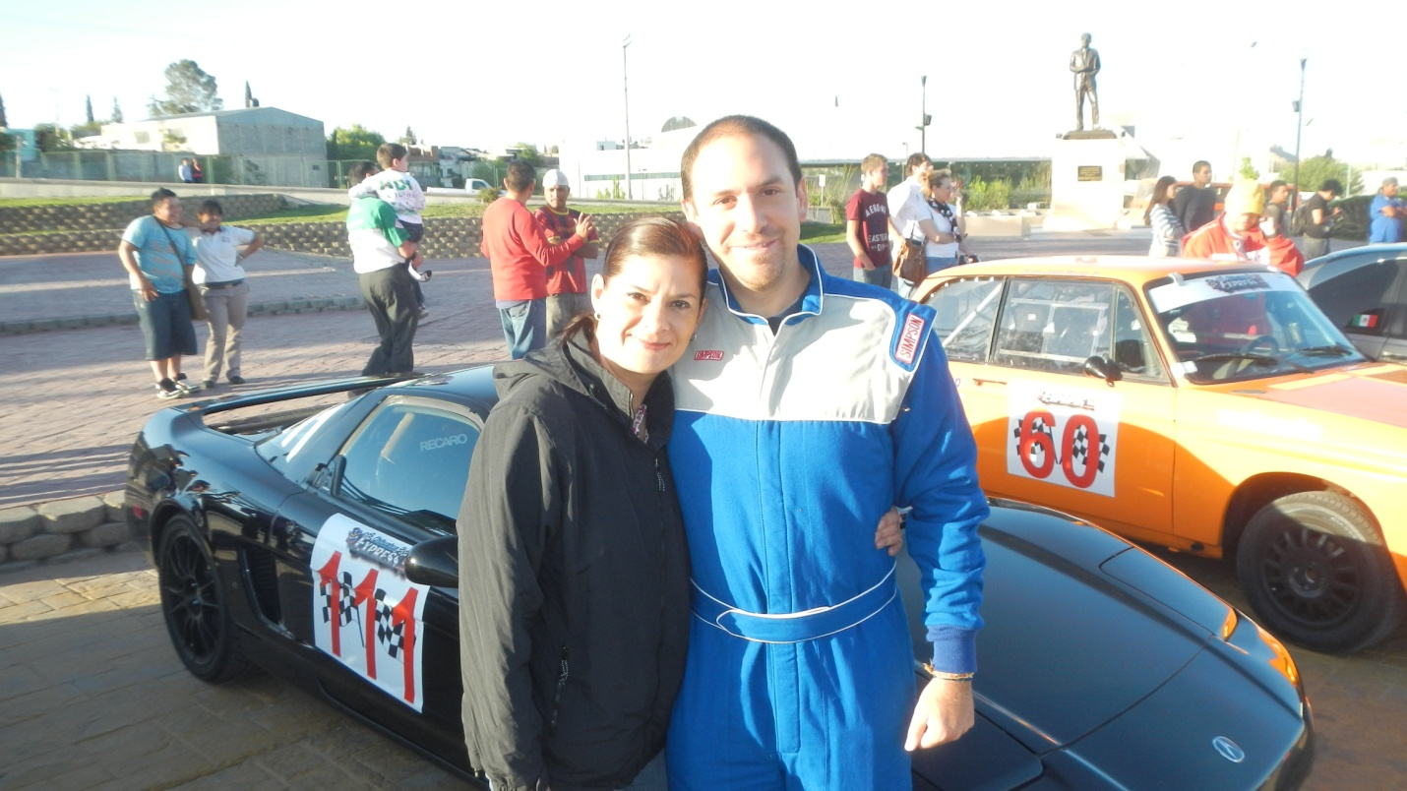

Roxana and Meme

**We Are Blessed**

Thursday evening, all the cars went to a plaza in downtown Chihuahua to have our ceremonial start. The cars were arranged in a big circle, and we all placed our helmets in an inner circle so they could be blessed by a native Indian ritual. We thought this was cool.

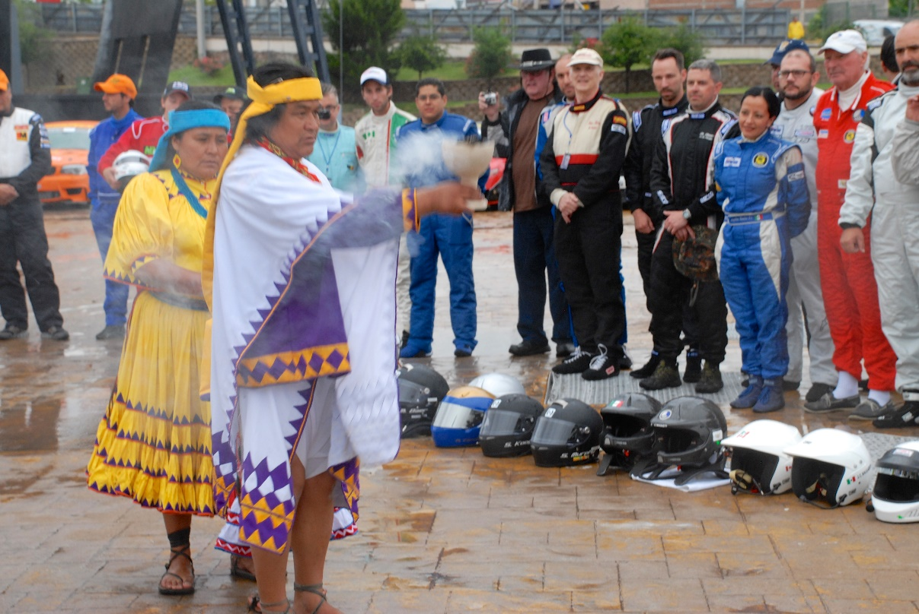

**Day One: Madera**

After running six stages out to Madera, enjoying the crowds of people gathered around the NSX in that town, and running the same six stages in the opposite direction from Madera back to Chihuahua, we were pleasantly surprised to find that we were fast enough to be in the hunt for a trophy.

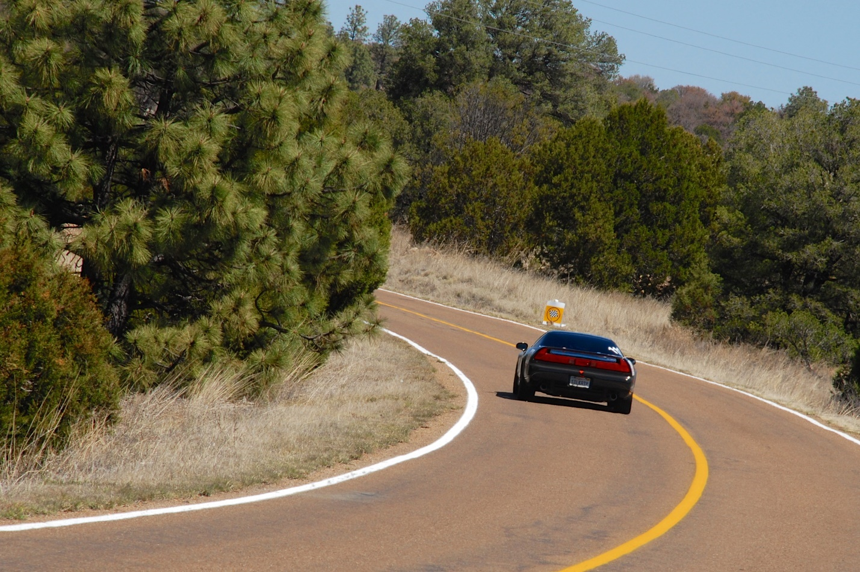

The fuel problem was truly vexing. Every chance I got, I opened the rear hatch and sprayed Freeze Mist onto the fuel lines, but that only helped for the first few kilometers and then it was back to sputtering and cutting out. When the sun finally got lower in the sky as we were on a long transit section back to the hotel, the fuel stopped vaporizing and the car was happy.

Val was also happy. She and Roxana had gone on a tour of some caverns near Chihuahua during the day, and Val was impressed with the colors and sights.

**Day 2: There’s No Fuel Like a Boiled Fuel**

The second day started with a very long transit out toward Copper Canyon (bigger, longer, wider, deeper than the Grand Canyon, but way out in the middle of nowhere). The car was running fine, and we were faster than any of our direct competitors for the championship in the first few stages.

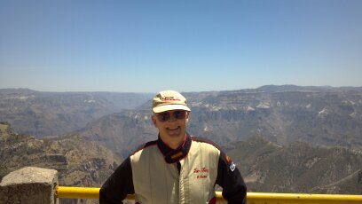

Copper Canyon

Then things went south. The sun beating in the rear hatch window boiled the fuel again and we started losing time. After 18 miserable sections, including the incident with the family, we had lost more than two minutes to our direct competitors. Maybe it’s a good thing we were slowed by the fuel vaporization problem: on one stage we passed two cars that had crashed into the woods on the same curve; and then of course there was the family.

When we got back to the hotel that night, I decided to remove the rear hatch and leave it off for the very hot run through the desert from Chihuahua to Ojinaga (Presidio, Texas) the next day. Meanwhile, Val and Roxana had had an excellent day visiting a Mennonite community.

**Day 3: The Acura El Camino**

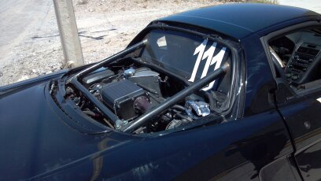

Without the solar cooker, we were flying even when the sun got high in the sky. As the race went on, I decided to back off and not take so many chances because we were definitely in the points if we finished. It worked.

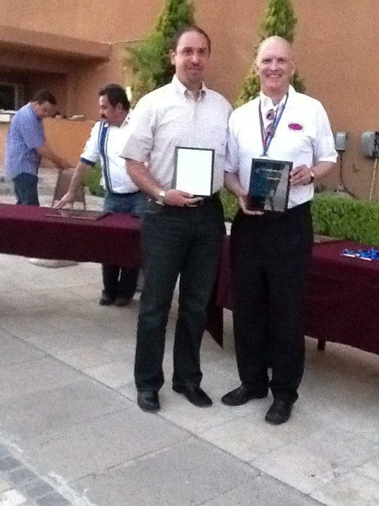

**The Championship**

After our successful race in Mexico in April, I teamed up with another Mexican co-driver of mine, Julian Torres, in May to win the Nevada Open Road Challenge at an average speed of 150 mph. Then at the end of the racing season, Meme and I cemented the championship by winning the Silver State Classic Challenge at an average of 145 mph.

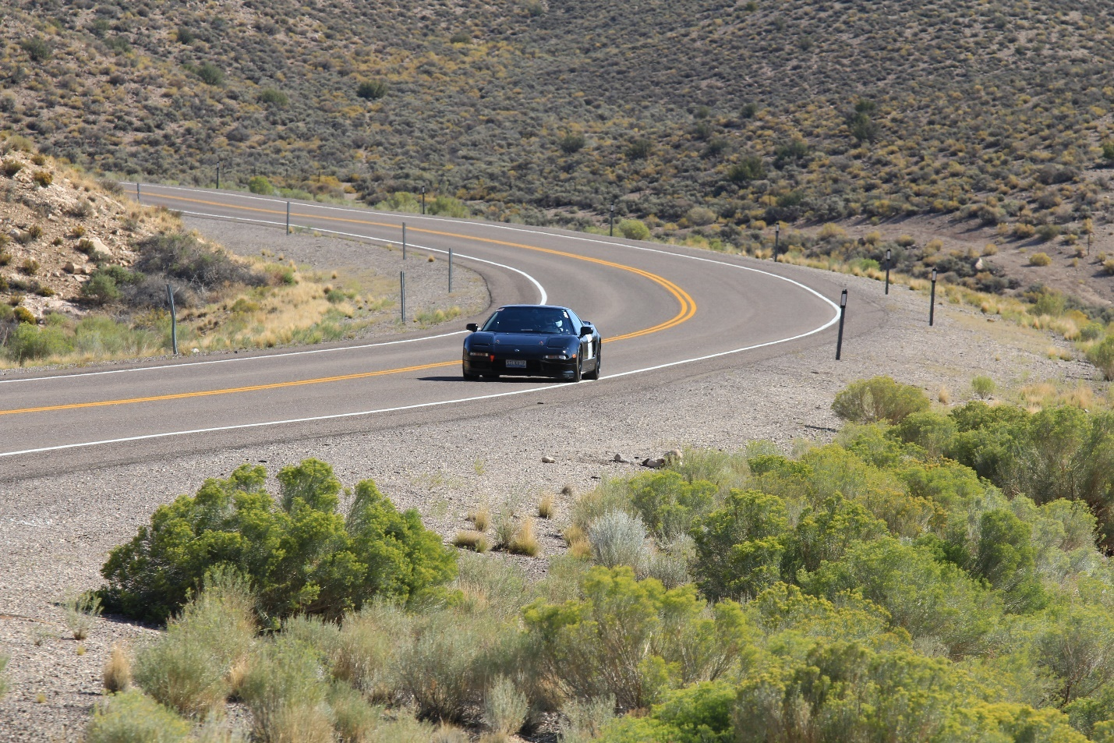

Kissing the Fog Line - Silver State Classic Challenge 145 mph 1st Place

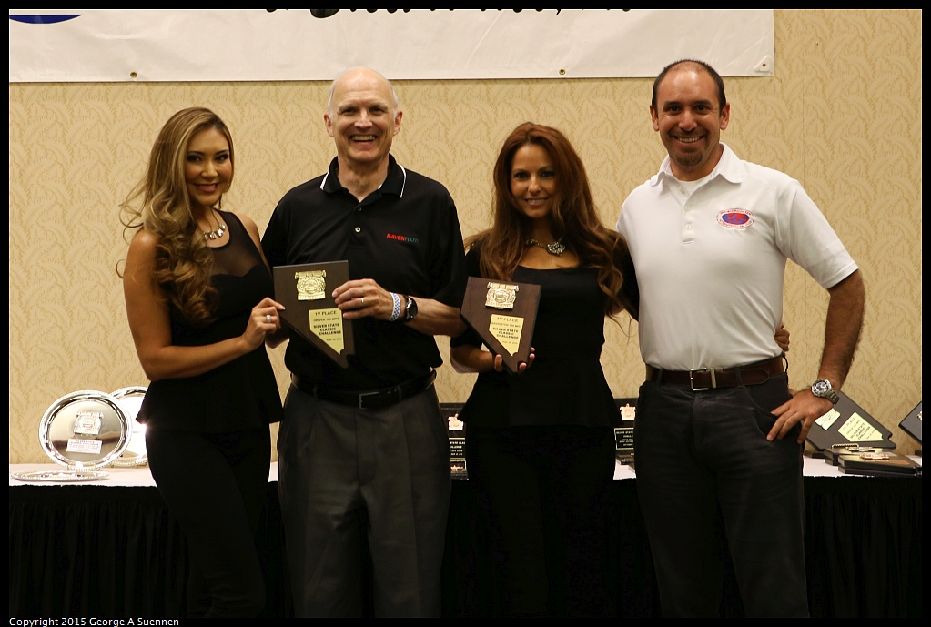

National Open Road Racing Champions

**You Tube Link**

[https://www.youtube.com/watch?v=COsaLHtmFJI](Road%20Racing%20in%20Mexico.docx)